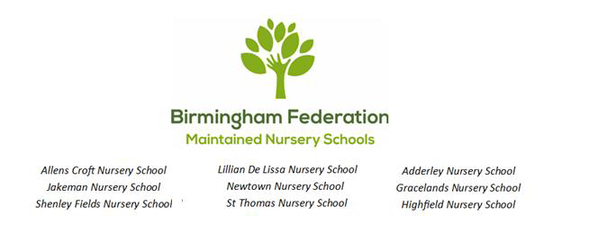
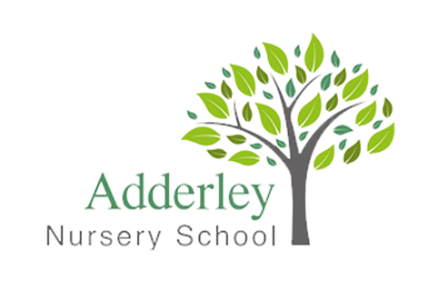
Charging and Remissions Policy Statement 2026–2027
Adderley Nursery School
The Birmingham Federation of Maintained Nursery Schools follows the policies and procedures of Birmingham City Council, including the BCC Financial Procedures Manual and Birmingham Safeguarding Children Partnership (BSCP), which includes the Government’s Prevent Strategy.
Date agreed by the Governing Body:
Sean Delaney, Chair of Governing Body

Contents
- Rationale
- Context
- Aims
- Charges
- Remissions
- Voluntary Contributions
- General
- Fees
- Parent/Carer Groups
- Other Charges That May Be Made by Our School
- RRS – The UN Convention on the Rights of the Child Links

Rationale
The Governing Body of Adderley Nursery School recognizes the valuable contribution that a wide range of additional activities, including trips, clubs, and enrichment opportunities, can make towards children’s education. We aim to promote and provide such activities as part of a broad and balanced curriculum, and as optional extras.

Context
The law states that education provided during school hours must be free. This includes materials, equipment, and transport provided by the Local Authority or the school. No child will be excluded from an activity because their parent/carer is unable or unwilling to contribute.

Aims
- To make school activities accessible to all children regardless of family income.
- To provide a fair process that enables activities to take place at minimal cost.
- To acknowledge the impact of these costs on the school’s budget.

Charges
The governing body reserves the right to make a charge in the following circumstances for activities organized by the school:
- Activities Outside School Hours: The full cost to each pupil of all approved activities deemed to be optional extras that are not a necessary part of the national curriculum.

Remissions
There is no obligation to make voluntary contributions, and children will not be treated differently based on their parents' ability to contribute. In cases of hardship, parents may apply in confidence for a full or partial remission of charges. The Head Teacher, in consultation with the Chair of Governors, will authorize remissions.

Voluntary Contributions
Voluntary contributions may be requested to cover costs of:
- Materials
- Bus fares
- Entrance fees
- Visitors and external workshops

General
The Governing Body may amend the categories of chargeable activity. Activities will not exclude children if voluntary contributions are not made.

Fees
Adderley Nursery School
Age Group | Rate per Hour
2–3 year olds | £6.00 (08:30 – 15:30)
3–4 year olds | £6.00
9months – 2 years | £12 (8.30-4.00)
*3–4 year old rates apply from the term following a child’s third birthday, in line with Local Authority funding.
Dinner : £2.10

Other Charges That May Be Made
- Two-year-old provision
- Out of School Club
- Holiday Club
- Top-up hours (beyond free entitlement)
- Parent groups/classes
- Training provided by the school
- Room hire/bookings

RRS – The UN Convention on the Rights of the Child Links
- Article 2 (non-discrimination): The Convention applies to every child without discrimination.
- Article 3 (best interests of the child): The best interests of the child must be a top priority in all decisions and actions that affect children.
- Article 23 (children with a disability): A child with a disability has the right to live a full and decent life with dignity and independence.
- Article 28 (right to education): Every child has the right to an education.
- Article 31 (leisure, play, and culture): Every child has the right to relax, play, and take part in a wide range of cultural and artistic activities.

